|  |
| --- |
| 新东方在线英语学习 |
| 新概念 1 册 |
| Lesson61-62 |



扫一扫。更多有趣的英语资讯。

# Lesson 61 单词讲解

1. feel: 感觉
2. look: 看起来
3. must: 必须
4. call: 叫、请
5. doctor: 医生
6. telephone: 电话

call sb. phone sb. give sb. a call

give sb. a phone

1. remember: 记得、记住

Do you remember?

oh, yeah, I remember. 哦，对， 我想起来了！

1. mouth: 嘴巴
2. tongue: 舌头 tang en

tongue twister 绕口令

1. bad: 严重的

a bad cold: 严重的感冒

1. cold: 感冒

a cold day(寒冷的一天)

a cold handshake (冷淡的,不热情) the cold color (冷色调)

a bad cold(感冒)

1. news: 消息

a piece of news Lesson 61 课文讲解

1. in bed（生病卧床）



He is in bed. He is in the bed.

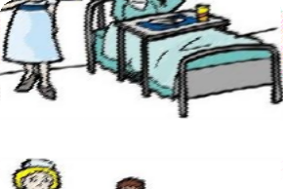

The man is in hospital.hao s bei dou

The nurse is in the hospital.

1. What’s the matter with him? What’s the matter with sb. ? What’s wrong with sb.? What’s up?
2. 所以他必须在床上呆一周。

So he must stay in bed a week.

So he must stay in bed for a week. for+ 段时间，表示长达

我今天上了 8 小时的课。

I have classes for eight hours today.

他必须在北京呆 10 年。

He must stay in Beijing for ten years.

1. That’s good news for Jimmy. for, 对于某人来说

英语对他来说很简单。

English is very easy for him.

北京的气候对她来说太干燥了。

It is too dry for her to stay in Beijing.

# Lesson 61 语法讲解



感官动词：

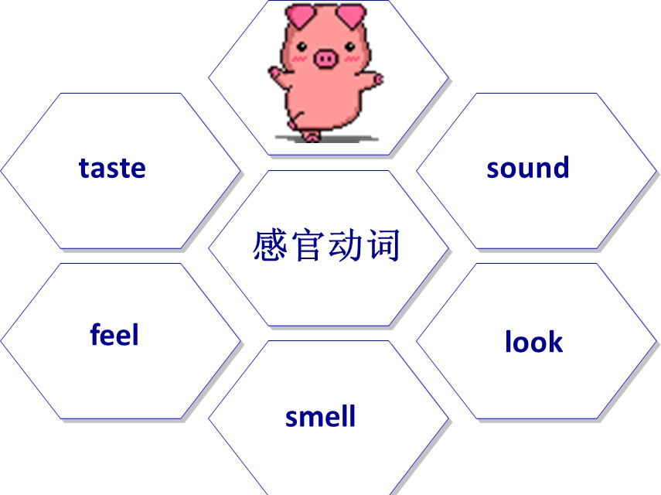Ａ. 感官动词－半系动词

1. 一半实义动词

do- does, drink-drinks

look-looks, sound-sounds, feel-feels, smell-smells, taste-tastes

do-did, look- looked…

1. 一半系动词

She is listening to music carefully. I eat my breakfast quickly.

**实义动词- 副词**You look young. It tastes good.

You are young

It is good

# 感官动词- 形容词

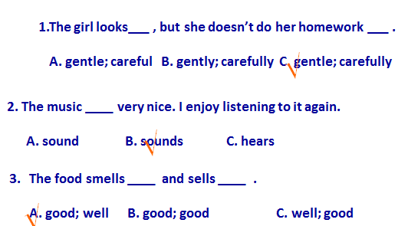

你像是很热。

You look very hot. 我觉得不舒服。 I feel ill\sick.

这道菜尝起来不错。The dish tastes good. tei si z

这歌听起来很熟悉。The song sounds familiar.fei mei li 啊

# Lesson 62 单词句型讲解

* 1. headache: 头疼hai dei ke
  2. earache: 耳朵疼ear rui ke
  3. toothache: 牙疼tu si ei ke
  4. stomach ache: 胃疼si dom kei ke

ache- 表示疼痛

n. backache 背疼

v. My head aches.我头疼。

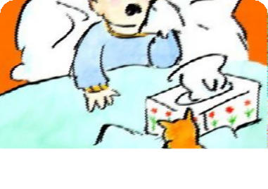

have a headache have a toothache have a cold

* 1. flu: 流感fu lu

禽流感: bird flu

猪流感: swine flu

have flu\ have bird flu…

* 1. measles: 麻疹mi zai ao si

have measles

* 1. mumps: 腮腺炎

have mumps

* 1. dentist: 牙医

scientist: 科学家sai n tai si te

tourist: 旅行的人

typist: 打字员

* 1. medicine: 药 （不可数）mai di sen
  2. temperature: 温度tai m per che er

have a temperature\ fever: 发烧生病&解决办法

He has a headache.

What must he do?

He must take an aspirin.

The baby has a temperature. What must we do?

He must see the doctor.

# Lesson 61&62 知识拓展

有关生病的问题

1. 感冒如何解决？
   1. stay in bed
   2. eat mild food
   3. drink more boiled water
   4. keep warm
2. 常见病症的表达:

He is under the weather.

He has a runny nose, sneezing or a scratchy throat. (他流鼻涕、打喷嚏，喉咙也很沙哑。)

He has an allergy. 他过敏了。Ai le zhei

I’m troubled by…

1. 常用患病的词:
   1. have\ has…
   2. take\ catch

Mary takes cold easily.

* 1. get…

I think she gets flu.

* 1. suffer from...sa fu er 受害于

They all suffer from swine flu.

